# Media Analysis - ChatGPT is the ‘Netscape moment’ for artificial intelligence’

## Short Summary

The article contrasts ChatGPT's capabilities with Netscape's influence on the World Wide Web, highlighting its advanced deep learning and LLMs while acknowledging AI's limitations such as lack of common sense, reasoning, and potential for misinformation, calling for enhanced systems with these abilities to complement AI advancements like Saudi Arabia's strategic AI investments.

## Summary

1. ChatGPT represents a "Netscape moment" for artificial intelligence (AI), sparking widespread excitement and interest, much like the World Wide Web's early adoption in the 1990s.  
2. The technology behind ChatGPT is a Large Language Model (LLM) built on deep learning and unsupervised learning techniques. It generates responses to questions, summarizes texts, and produces large amounts of text content based on prompts.  
3. LLMs can automatically create contract skeletons for global law firms without human intervention, but they lack knowledge of the world, common sense, or reasoning abilities.  
4. Current limitations include their inability to tackle complex tasks like riddles or perform mathematics, leading to potential issues with hallucinations and misinformation dissemination.  
5. To address these challenges, AI models need augmentation by systems that mirror human-like thinking, such as understanding the world, common sense, ethics, and reasoning abilities.  
6. Rapid advancements in LLMs will continue, necessitating further augmentation to align with how human minds operate, including near-instantaneous decision-making capabilities like object identification or sentence comprehension.  
7. A second type of slower thinking involves systems requiring more conscious and logical processing. Foundation models, such as generative pre-trained transformers, represent a rapidly evolving AI platform that can be extended with domain-specific data to create new business applications at minimal marginal cost.

## Question 1:

How do the media (in our case = the sample we are analyzing) frame the public discussion about ChatGPT? Are there certain **metaphors** that keep cropping up?

In Arabic newspapers, metaphors that frequently emerge when discussing ChatGPT include comparing it to the Netscape moment for AI, describing it as a Large Language Model LLM , using terms like 'autocomplete on steroids', and highlighting potential negative consequences such as high-tech plagiarism or misinformation factories.

## Question 2:

Which role does the Arabic World play in the field of Artificial Intelligence in this article according to the author? Answer with 'Not mentioned' if not applicable.

The author highlights that the Kingdom, through organizations like the Saudi Data and AI Authority, extensive multi-decade efforts to train local engineers, scientists, and technologists, as well as investments and programs launched by national champions such as Aramco, is exceptionally well-placed to capitalize on the opportunities inherent in Arabic language-based AI systems like ChatGPT. This includes localization and extension of LLMs for regional languages and dialects, and utilization of knowledge embedded in domains where Saudi Arabia is a natural leader, such as energy, to develop foundation models available broadly.

## Question 3:

How helpful is Artificial Intelligence for the Arabic world based on this article?

The article suggests that AI holds substantial potential for the Arabic world, particularly in enhancing productivity during economic hardships and aiding in addressing demographic challenges. However, it also points out the current limitations of AI technologies like ChatGPT, which necessitate further development to overcome issues related to lack of world knowledge, common sense, reasoning abilities, and susceptibility to misinformation generation.

## Question 4:

What is the final message of the article that the author wants to convey? Keep your answer short and precise!

Transformative potential of advanced AI technologies, cautions about limitations, emphasizes combining AI with human capabilities for maximum impact during economic challenges, highlights Saudi Arabia's strategic advantages in data-driven AI development.

## Sentiment

The sentiment is 4

## Entities

GPT, IBM, LLM, exempli ed, ChatGPT, Arab News', ANTHONY BUTLER, AI, Disclaimer Views, Anthony Butler, the Saudi Data, AI Authority, Aramco

## Topic Clusters

### Cluster: ChatGPT and AI Impact on Society

Unsupervised Learning, Data Localization, Saudi Arabia, Foundation Models

## Word Clouds

### Wordcloud of content

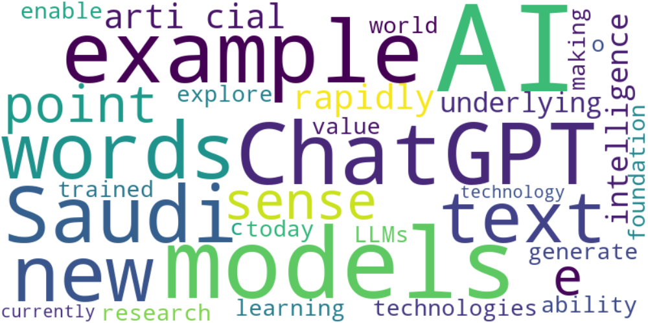

Top 10 words:

- AI: 13

- models: 8

- ChatGPT: 6

- example: 6

- new: 5

- words: 5

- Saudi: 5

- arti: 4

- cial: 4

- text: 4

### Wordcloud of summary



Top 10 words:

- like: 4

- AI: 3

- human: 3